**Innovative heritage products**

Kural logo

The voice of wrights

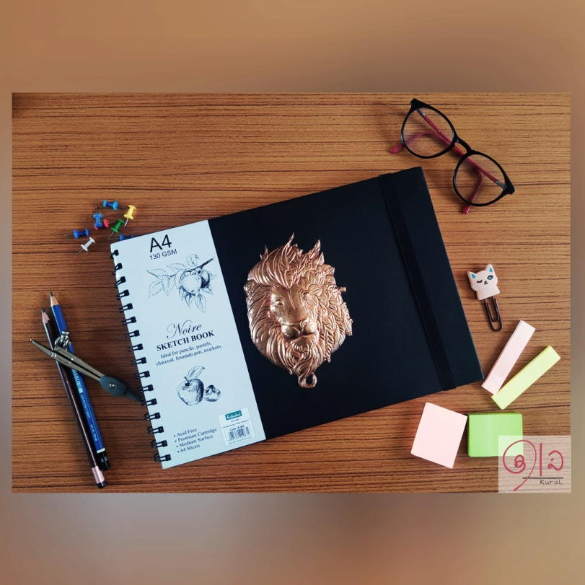

People Purpose Pursuit

Shop with us

**What we do**We design innovative products based on heritage crafts to showcase the dexterity of the artisans.

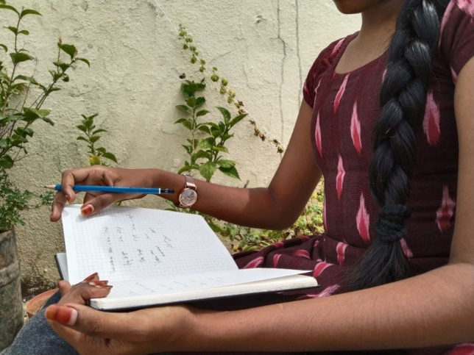

**Our vision**Our vision is to break the barrier between the native crafts and technology and bring in the spotlight for our own arts.

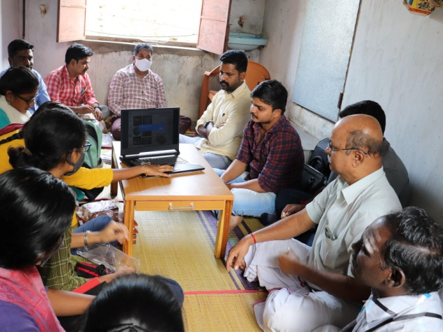

**Services**Heritage craft based innovative products

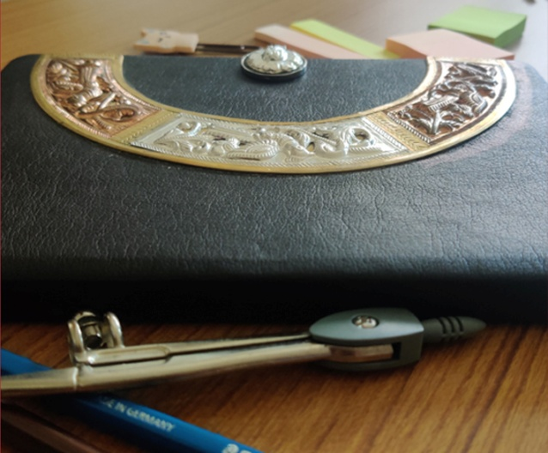

Heritage based innovative accessories

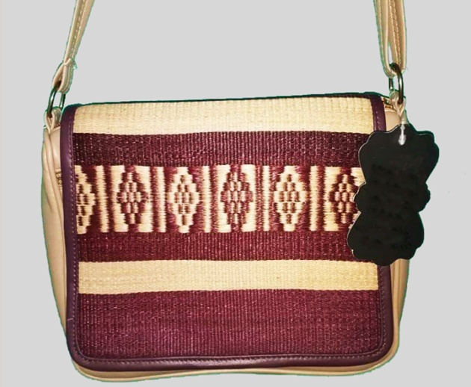

Customized coconut shell jewelry

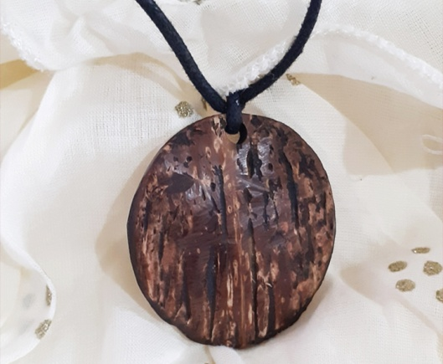

Traditional toys in a modern note

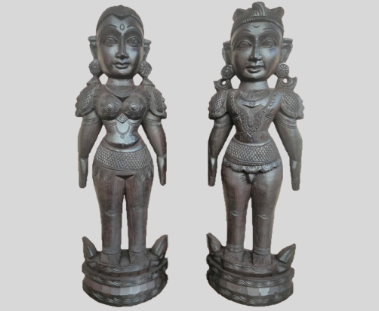

**Meet our folks**

(Art plate)

The real Masters of metals without a doctrine in metallurgy. They work to perfection. Meet our craftsmen working with us to deliver our innovative products in an alluring manner.

Our people:

Mr. Shankaran – Master craftsman

Mr. Kumar

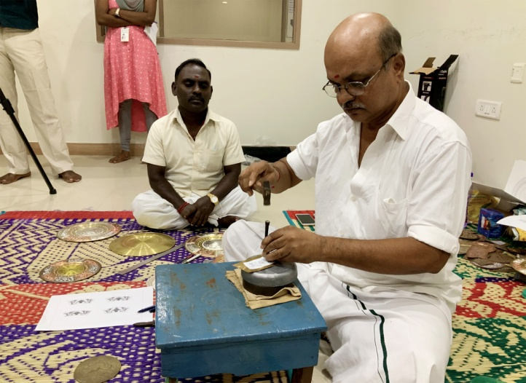

(Bronze icons)

Stapathis are ruling fire and metal in an awe-inspiring way. The vast story behind the Utsavar procession icons dates back to Chola dynasty and still Swamimalai region owns this craft.

Our people:

Mr. Venkatesan – Master craftsman

Mr. Saravanan

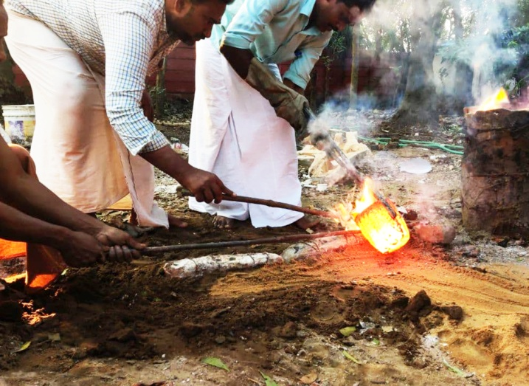

(Pattamadai mats)

The endeavors of the women who put in their soul into weaving lengths and lengths of mats. These mats are known for extended durability and it prevents excessive heat gain in the body while used for a long time.

Our people:

Mrs. Haiwa Beevi – Master weaver

Mrs. Ayeesha Baanu

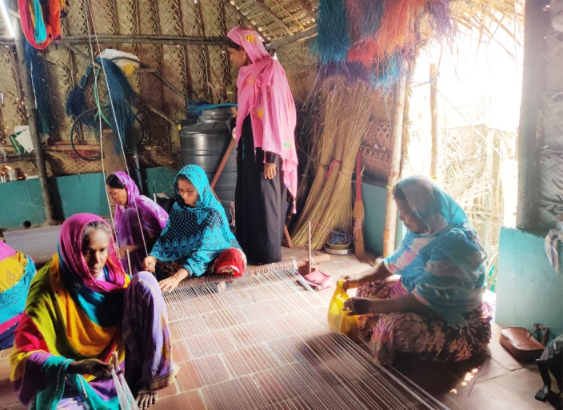

(Ayyampettai Kutni)

A great effort indulged in reviving this heritage craft of Tamilnadu – the kutni fabric. Warp and weft bumping into each other to reveal the sheeny textile. Being traditional craftsmen, they are open to contemporary designs. Visit Neer boutique for more updates

Our People:

Mr. Selvaraj – Master weaver

Mr. Govindas

